
CMR INSTITUTE OF TECHNOLOGY
ACADEMIC YEAR 2025-2026(Even)
Flipped Classroom Plan
DEPARTMENT OF Information Science and Engineering

Subject code | BCS401 | Course Name | ANALYSIS AND DESIGN OF ALGORITHM
Semester / Section | IV-C | Prepared By | KAVITHA P
Curriculum Gap Identified: | NIL

Summary of Flipped Classes conducted:
Sl No. | Topic | Date | Flipped class / Video Session (Choose from drop down) | Total number of students
1 | Quick sort Analysis & Binary Tree Traversal | 27/03/26 | Flipping the Teacher | 50
2 | Balanced Search Trees |  | Flipping the Teacher
3 | Decision tree |  | Flipping the Teacher

Detailed Report
1 | Sorting by Counting: Comparison counting sort | Date : 27/03/2026 | Standard Inverted Flipped Classroom | No. of students:  50
Materials Shared Before Class

Analysis and design of algorithms material was shared with students through Google . The proof link of study Materials is shared in advance and the link is given below.
https://www.vtustudymaterials.online/ise/sem4/

Conduction of Flipped Classroom
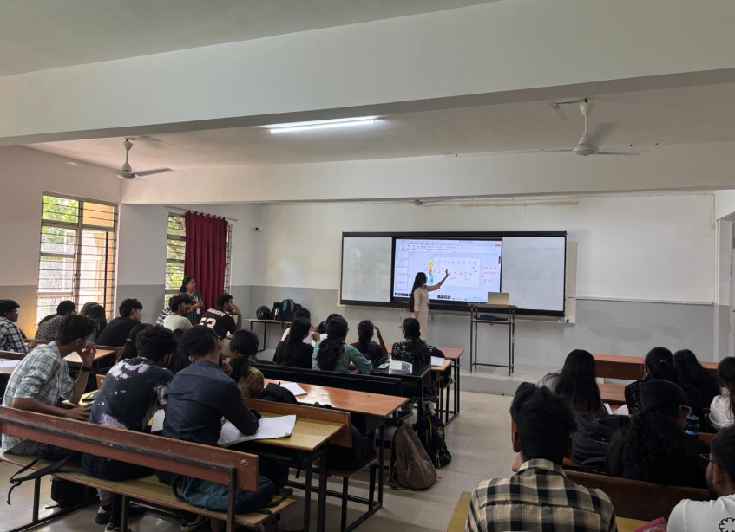
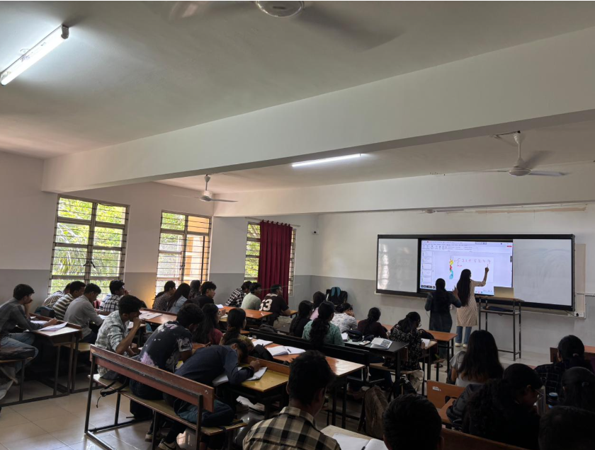

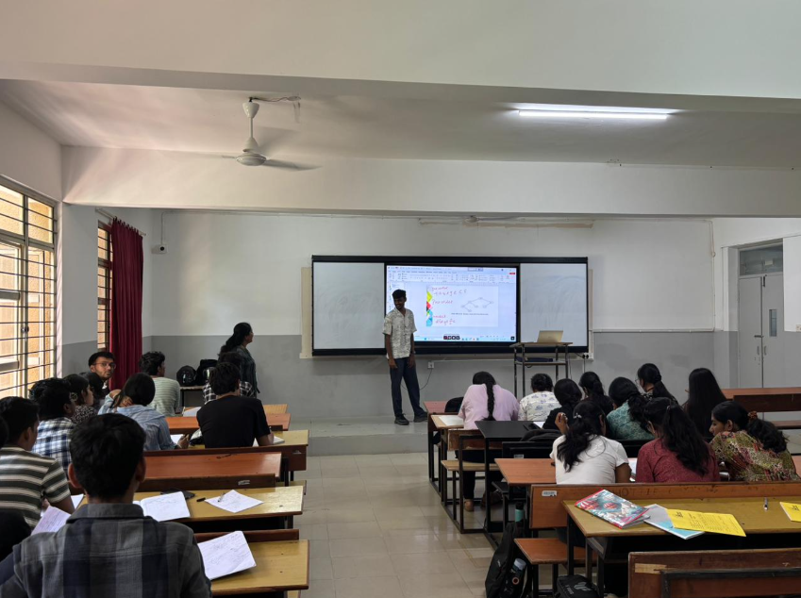

Evaluation :
Students were randomly selected and asked to analyze time complexity.
Outcome:
The outcome of this flipped classroom is:
The environment of the ADA keywords.
To push students to higher order blooms levels such as L2 and L3.
The PO’s and PSO’s that are addressed by doing this flip class are as follows:
PO’s- 1,2,3,4,6,12
PSO’s- 1,2,3,4

